Exercise 1: Real (Noisy) Data — Does the Line Still Fit Well? (Intermediate)
Goal: Understand what happens when data isn't perfectly linear — this is what real-world data looks like.
python

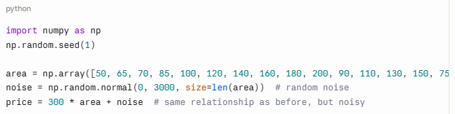

Tasks:
- Train a simple linear regression model (area → price) on this noisy data
- Plot the scatter points and the best-fit line — notice the line no longer touches every point
- Calculate MSE, MAE, and RMSE
- Increase the noise (np.random.normal(0, 10000, ...)) and retrain — what happens to RMSE? Does the line change much?
Question to answer: Why doesn't the best-fit line pass through every point anymore? What does a higher RMSE tell you about the reliability of this model?

Exercise 3: Manual Gradient Descent (Advanced)
Goal: Implement gradient descent by hand (no sklearn) and confirm it matches LinearRegression.
Using the original clean dataset (area vs price):
python
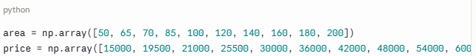

Tasks:
- Write your own gradient descent loop from scratch, following this pseudocode structure:
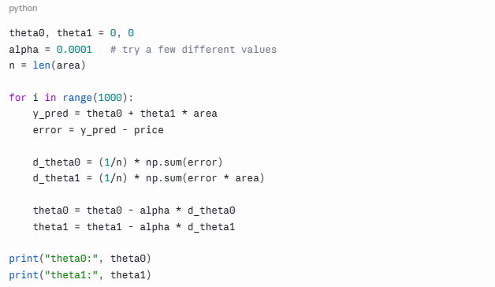
- Compare your final theta0 and theta1 to model.intercept_ and model.coef_ from sklearn
- Try changing alpha to something much larger (e.g., 0.01) — what happens? Does the model still converge?
- Plot cost (J) vs iteration number to visualize the learning process
Question to answer: What happens to your theta values if alpha is too large? Why does that happen, based on what you learned about the learning rate?

